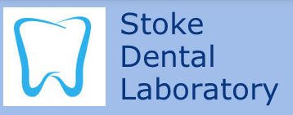
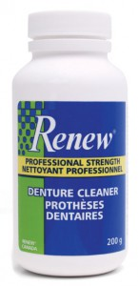
Renew Denture Cleaner

KEY FEATURES OF RENEW DENTURE CLEANER
- Outstanding product quality and professional strength performance
- We are the manufacturer so quality and supply are consistent
- Guaranteed to remove: Tobacco, Iron, Plaque, Coffee, Calcium, Calculus, Tea, Tartar and Bacteria (Money Back Guarantee)
- Proven in the marketplace for more than 25 years
- Can be used with Molloplast-B and many Detax products
- Is also safe on mouth guards, sport guards, thermal based oral appliances, Invisalign, Valplast and any other acrylic oral appliance

*Print this page to get 10% off at Stoke Dental Laboratory

